

Name: Sajjal Tariq
Roll No: 10011
Section: A
Submitted To: Sir Zohaib Khan

LAB NO. 06
Built-In Functions

To learn and practice built-in functions using DML commands

Instructions
▪ This is individual Lab work/task.
▪ Complete this lab work within lab timing.
▪ Discussion with peers is not allowed.
▪ You can consult any book, notes &amp; Internet.
▪ Copy paste from Internet will give you negative marks.
▪ Lab work is divided into small tasks, complete all tasks sequentially.
▪ Show solution of each lab task to your Lab Instructor.
▪ Paste your solution (i.e. code) in given space under each task.
▪ Also make a zip/rar archive of all lab tasks and upload this file on LMS before
leaving lab.
▪ In-Lab Exercises/Tasks

.

FACILITIES REQUIRED AND PROCEDURE
Facilities required to do the experiment
SNo Facilities Required Quantity
1 System 1
2 Operating System Windows 10
3 Front End Java
4 Back End Oracle 11g, MySQL
Procedure for doing the experiment
Step Detail
1 Built-in Functions

Function is a group of code that accepts zero or more arguments and
both return one or more results. Both are used to manipulate individual
data items. Operators differ from functional in that they follow the
format of function name (arg..). An argument is a user defined
variables or constants. Most operators accept at most 2 arguments
while the structure of functions permit to accept 3 or more arguments.
Function can be classifies into single row function and group functions.

2 Single Row functions

A single row function or scalar function returns only one value for every
row query in table. Single row functions can appear in a select
command and can also be included in a where clause. The single row
function can be broadly classified as, o Date Function o Numeric
Function o Character Function o Conversion Function o
Miscellaneous Function The example that follows mostly uses the
symbol table “dual”. It is a table, which is automatically created by
oracle along with the data dictionary.

3 Date Function

The date function operates on date values and produce outputs, which
also belong to date data type except for months, between, date
function returns a number.

4 Aggregate Functions

A group function returns a result based on group of rows

SQL COMMANDS

Date Function
add_month
This function returns a date after adding a specified date with specified number of
months.
Syntax: Add_months(d,n); where d-date n-number of months
Example: Select add_months(sysdate,2) from dual;

last_day
It displays the last date of that month.
Syntax: last_day (d); where d-date
Example: Select last_day („1-jun-2009‟) from dual;

months_between
It gives the difference in number of months between d1 &amp; d2.
Syntax: month_between (d1,d2); where d1 &amp; d2 –dates
Example: Select month_between („1-jun-2009‟,‟1-aug-2009‟) from dual;

next_day
It returns a day followed the specified date.
Syntax: next_day (d,day);
Example: Select next_day (sysdate,‟wednesday‟) from dual

round

This function returns the date, which is rounded to the unit specified by the format
model. Syntax : round (d,[fmt]);
where d- date, [fmt] – optional. By default date will be rounded to the nearest day
Example: Select round (to_date(„1-jun-2009‟,‟dd-mm-yy‟),‟year‟) from dual;
Select round („1-jun-2009‟,‟year‟) from dual;

Numeric Functions
Command Query Output
abs(n)
ceil(n)
exp(n)
floor(n)
power(m,n)
mod(m,n)
round(m,n)
trunc(m,n)
sqrt(m,n)

select abs(-15) from dual;
select ceil(55.67) from dual;
select exp(4) from dual;
select floor(100.2) from dual;
select power(4,2) from dual;
select mod(10,3) from dual;
select round(100.256,2) from dual;
select trunc(100.256,2) from dual;
select sqrt(16) from dual;

15
56
54.59
100
16
1
100.26
100.23
4

Character Functions

Command Query Output
initcap(char);
lower(char);
upper (char);
ltrim(char,[set]);
rtrim(char,[set]);
substr(char,m,n)
;

select initcap(‘hello’) from dual;
select lower (‘HELLO’) from dual;
select upper (‘hello’) from dual;
select ltrim (‘cseit’, ‘cse’) from dual;
select rtrim (‘cseit’, ‘it’) from dual;
select substr (‘information’, 3, 4) from dual;

Hello
hello
HELLO
it
cse
form

replace(char,
search string,
replace string);

select replace(‘jack and jue’,’j’,’bl’) from dual; black
and blue

Conversion Functions
to_char()
Syntax: to_char(d,[format]); This function converts date to a value of varchar type in a
form specified by date format. If format is negelected then it converts date to varchar2 in
the default date format. Example: select to_char (sysdate, ‟dd-mm-yy‟) from dual;

to_date()
Syntax: to_date(d,[format]);
This function converts character to date data format specified in the form character.
Example: select to_date(„aug 15 2009‟,‟mm-dd-yy‟) from dual;

Miscellaneous Functions
uid – This function returns the integer value (id) corresponding to the user currently
logged in.
Example: select uid from dual;
user – This function returns the logins user name.
Example: select user from dual;
nvl - The null value function is mainly used in the case where we want to consider null
values as zero.
Syntax; nvl(exp1, exp2) If exp1 is null, return exp2. If exp1 is not null, return exp1.
Example: select custid, shipdate, nvl(total,0) from order;
vsize: It returns the number of bytes in expression.
Example: select vsize(„tech‟) from dual;

Group Functions
A group function returns a result based on group of rows.
count(distinct col_name) – It avoids the repeated and null values.
Example: select count(distinct ordid) from order;

GROUP BY Clause
This allows us to use simultaneous column name and group functions.
Example: Select max(percentage), deptname from student group by deptname;

HAVING Clause
This is used to specify conditions on rows retrieved by using group by clause.
Example: Select max(percentage), deptname from student group by deptname having
count(*)&gt;=50;

Special Operators
In / not in – used to select a equi from a specific set of values
Any - used to compare with a specific set of values
Between / not between – used to find between the ranges
Like / not like – used to do the pattern matching

Tasks

Q1: Display all the details of the records whose employee name starts with ‘A’.
Answer:
Create Table First: CREATE TABLE worker (
2 worker_id NUMBER(6),
3 worker_name VARCHAR2(20),
4 job VARCHAR2(10),
5 deptno NUMBER(3),
6 salary NUMBER(7,2)
7 );
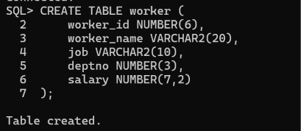
INSERT INTO worker VALUES (1, 'Sajal Fajar', 'CEO', 10, 95000);
SQL> INSERT INTO worker VALUES (2, 'Mairah Kanwal', 'Manager', 20, 60000);
SQL> INSERT INTO worker VALUES (3, 'Ali', 'Guard', 10, 25000);
SQL> INSERT INTO worker VALUES (4, 'Mamon', 'Chef', 30, 35000);
SQL> INSERT INTO worker VALUES (5, 'Moin', 'Clerk', 20, 30000);
SQL> INSERT INTO worker VALUES (6, 'Furqan', 'Sweeper', 30, 20000);
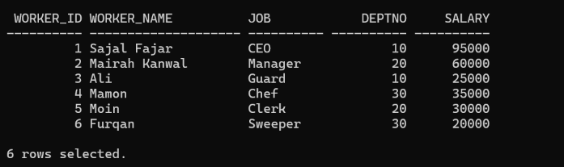
SELECT * FROM worker
2 WHERE worker_name LIKE 'A%';
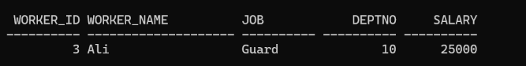
Q2: Display all the details of the records whose employee name does not starts
with ‘A’.
Answer:
SELECT * FROM worker
WHERE worker_name NOT LIKE 'A%';
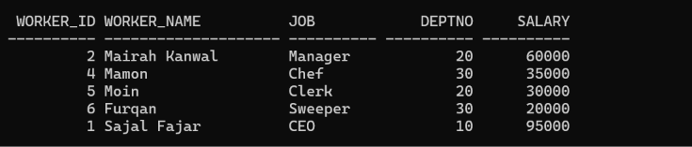rv

Q3: Display the rows whose salary ranges from 15000 to 30000.
Answer:
SELECT * FROM worker
2 WHERE salary BETWEEN 15000 AND 30000;
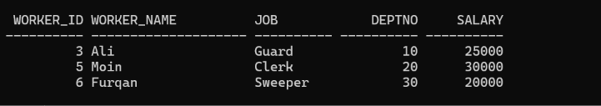

Q4: Calculate the total and average salary amount of the emp table.
Answer:
SQL> SELECT SUM(salary), AVG(salary)
2 FROM worker;
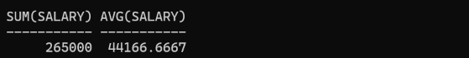

Q5: Count the total records in the emp table.
Answer:
SELECT COUNT(*) FROM worker;
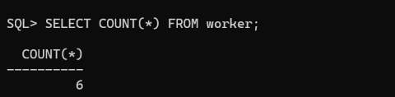
Q6: Determine the max and min salary and rename the column as max_salary and min_salary.
Answer:
SELECT MAX(salary) AS max_salary,
2 MIN(salary) AS min_salary
3 FROM worker;

Q7: Display month(s) between today and hire date.
Answer:
First Add Dates:
ALTER TABLE worker
2 ADD hire_date DATE;
SQL> UPDATE worker SET hire_date = DATE '2024-01-15'
2 WHERE worker_id = 1;
SQL> UPDATE worker SET hire_date = DATE '2024-03-10'
2 WHERE worker_id = 2;
SQL> UPDATE worker SET hire_date = DATE '2024-06-20'
2 WHERE worker_id = 3;
SQL> UPDATE worker SET hire_date = DATE '2024-08-05'
2 WHERE worker_id = 4;
SQL> UPDATE worker SET hire_date = DATE '2025-01-12'
2 WHERE worker_id = 5;
SQL> UPDATE worker SET hire_date = DATE '2025-04-18'
2 WHERE worker_id = 6;
Hire Date:
SQL> SELECT worker_name,
2 MONTHS_BETWEEN(SYSDATE, hire_date) AS months
3 FROM worker;
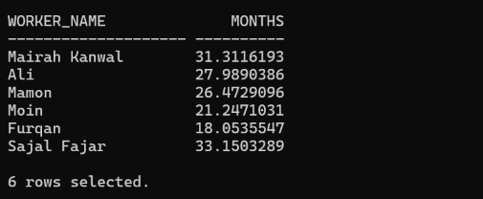
Q9: Find how many job titles are available in employee table.
Answer:
SELECT COUNT(DISTINCT job) AS total_jobs
2 FROM worker;
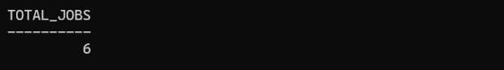
Q10: Display annual salary of employees along with ename, sal, and comm.
Answer:
First Add Comission Column:
SQL> ALTER TABLE worker
2 ADD comm NUMBER(7,2);
SELECT worker_name, salary, comm,
2 salary * 12 AS annual_salary
3 FROM worker;
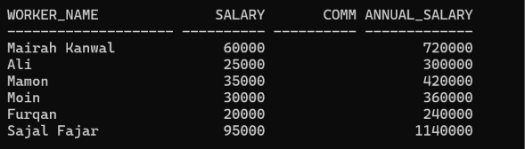

OUTCOME

Thus the queries using the different intrinsic functions were executed successfully.

QUESTIONS AND ANSWERS
Define function?
Function is a group of code that accepts zero or more arguments and both return one or more results. Both are used to manipulate individual data items.
Write two types of functions.
Single row functions
Aggregate functions

What are single row functions?
A single row function or scalar function returns only one value for every row in a query in a table. Single-row functions can appear in a SELECT command and can also be included in a WHERE clause. The single-row function can be broadly classified as:
Date Functions
Numeric Functions
Character Functions
Conversion Functions
Miscellaneous Functions

List some character functions.
initcap(char);
lower (char);
upper (char);
ltrim (char,[set]);
rtrim (char,[set]);

